*Florida International University*

*School of Computing and Information Sciences*

CIS 4911 - Senior Capstone Project

Software Engineering Focus

Feature Document

User Story #954

**Team Member:**

Johnatan Jensen

**Product Owner(s)**:

Mohsen Taheri

**Mentor(s)**:

Mohsen Taheri

**Instructor**: Masoud Sadjadi

**User Story** Testing and modifying students application process

* As a developer, i would like to test and modify the process of applying a project by a student, so that i know it works well.

Acceptance Criteria

* <http://vip.fiu.edu/#/studentConfirmation/> must work well.

**Use Case**

1. **Student confirms account information and project application**   
   Participating Actors: Student  
     
   Entry Condition: Student chooses project they wish to apply for  
     
   Events Flow:
2. The student chose the project they wish to apply for
3. Student is redirected to the ../student-confirmation page
4. The student reviews all their information on their account and the project they wish to apply for is correct
   1. The student adjusts any incorrect information
5. The student, when ready, presses the “submit & save” button
6. The student is redirected to the projects page and the use case finishes

**Use Case Diagram**

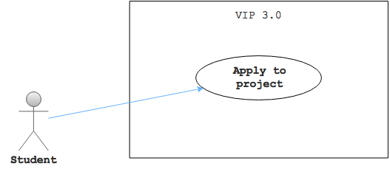

**Sequence Diagram**

Sequence_diagram_1.jpg

**Class Diagram**

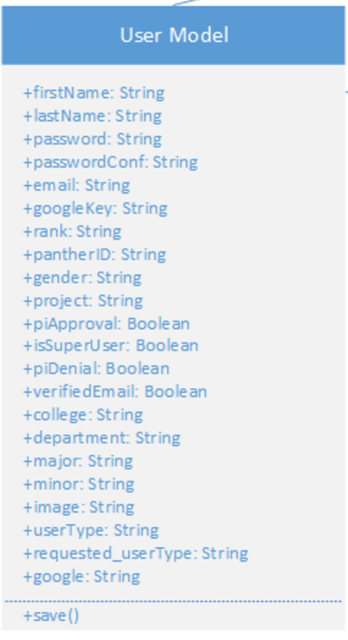

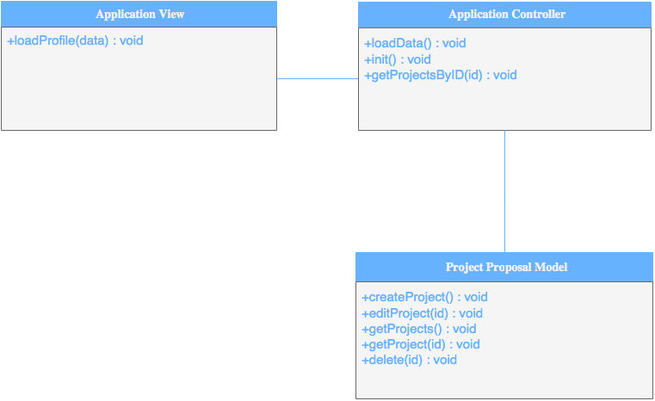

**Unit & Integration Tests**

* **Test Case 1**
  + **Purpose:** Test that the submit button overwrites the students information array with the new data if they fixed any issues i.e. gender, college, etc...
  + **Precondition:** Valid values are put in the student confirmation form and at least one input varies from the student's current information stored on the account
  + **Expected Result:** The database stores the new students updated information. The student is redirected to previous page.
  + **Actual Result:** Student information was not updated.
  + **Status: SUCCESS**
* **Test Case 2**
  + **Purpose:** Test that the projects array is updated to show a new student has joined the project
  + **Precondition:** Student applies to a project that isn’t full already
  + **Expected Result:** The student submitted and confirmed his information. The projects array is updated and shows the student as subscribed to it
  + **Actual Result:** Project is not adding a student
  + **Status: SUCCESS**
* **Test Case 1 (Sunny Day)**
  + **Purpose:** Test that the page is grabbing the user's information for pre-filling the form
  + **Precondition:** Student is signed in and visits the ../studentConfirmation page
  + **Expected Result:** The form is filled out properly with the students information retrieved from their profile
  + **Actual Result:** The form is filled out properly with the students information retrieved from their profile
  + **Status: SUCCESS**
* **Test Case 1 (Rainy Day)**
  + **Purpose:** Test that student cannot submit application without necessary fields
  + **Precondition:** Student is signed in and visits the ../studentConfirmation page and submits the form without selecting a project and/or semester
  + **Expected Result:** Form is submitted causing exception error
  + **Actual Result:** An error messages asks them to select a semester or project
  + **Status: SUCCESS**

**Visual User Guide**

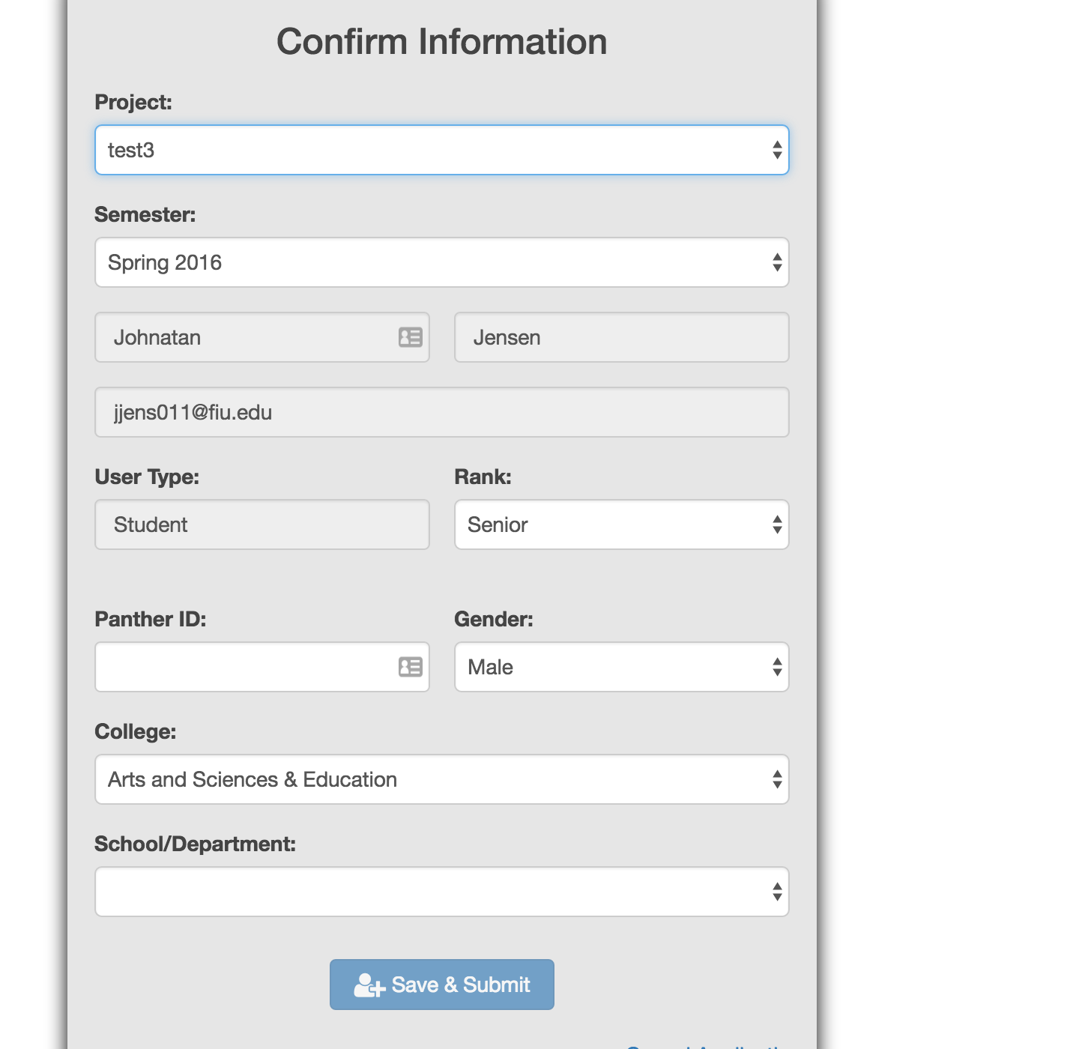

Student fills out form and chooses desired project

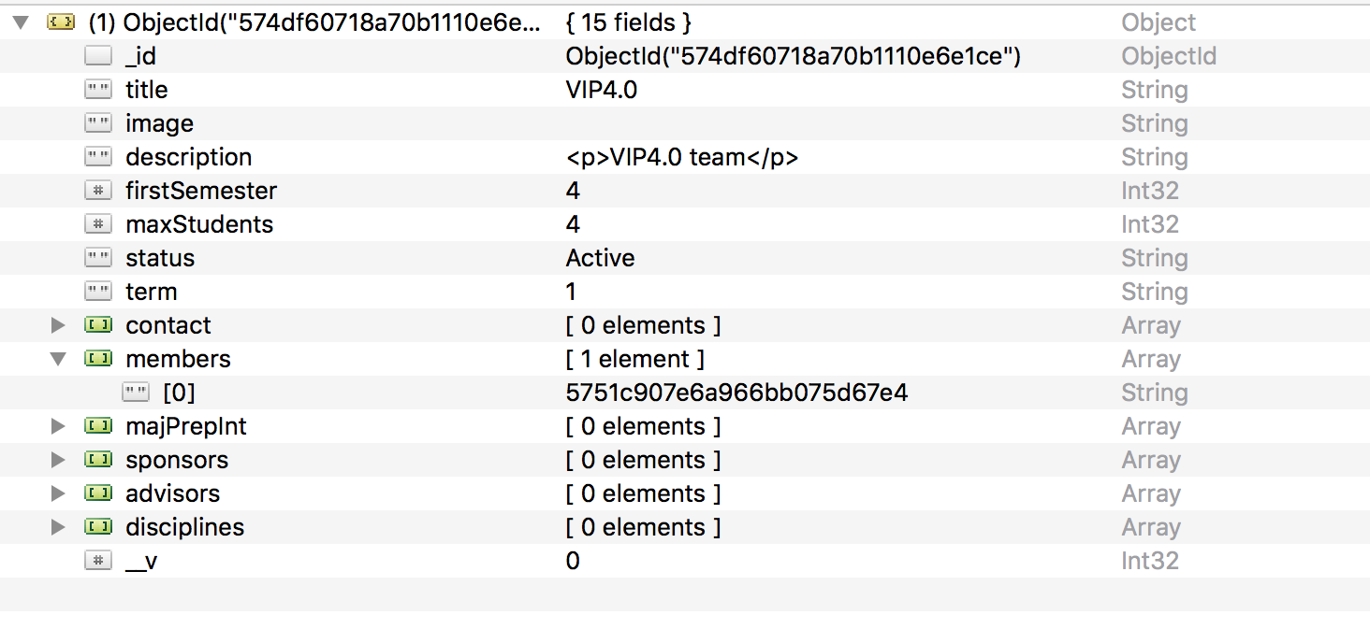

On submit the student is registered to the project